Written by Mandela Mathia, Directed by Jessica Arthur
Belvoir Street Theatre 2024

Suggested Duration
4 x lesson activities (allow approximately 60 minutes each)

Rationale
The following learning sequence is designed to develop students' capacity as writers. Using Mandela Mathia’s Lose to Win as a model text, students will work to develop their own life writing pieces. In their writing and their own experimentation with form, students will reflect on the experiences of the playwright, as well as their own, to broaden their understanding of their world and the human condition.

Student Focus Questions
- How do stories make a difference to our lives?
- Why is storytelling important when recognising the complex nature of humanity?
- How can we seek inspiration from non-fiction texts and utilise this in our own storytelling?

Success Criteria
Students:
- develop their understanding of life writing as a concept and process
- take inspiration from their world and the world of others
- confidently use a range devices to add depth and symbolic meaning to their writing.

NSW English Curriculum Links and Textual Concepts
EN5-URC-01 investigates and explains ways of valuing texts and the relationships between them

Literary value
Analyse and evaluate how thematic and aesthetic qualities of a text contribute to the different ways an audience questions and negotiates the value of the text in particular contexts
EN5-ECA-01 crafts personal, creative and critical texts for a range of audiences by experimenting with and controlling language forms and features to shape meaning

Writing
- Develop a personal and informed voice that generates ideas and positions an audience through selection of appropriate word-level language and text-level features
- Experiment with language to create tone, atmosphere and mood
- Apply narrative voice to depict complex ideas and enhance engagement

Representing
- Experiment with a variety of codes and conventions to create aesthetic qualities that have the power to communicate ideas and influence viewpoints in own texts
- Compose visual and multimodal texts to express complex ideas, using a range of digital technologies where appropriate

Text features
- Express ideas, using appropriate structures for purpose and audience, that reflect an emerging personal style
- Use the structural conventions of imaginative texts purposefully, including shaping complex complications and conflicts, and crafting authentic characters, to depict ideas
- Experiment with the process of transformation to create texts with new meaning
- Use the structural conventions of discursive texts purposefully, including the transition between personal and abstract texts, to present complex and nuanced ideas
- Experiment with a combination of modes for specific effect and impact

Word-level language
- Use a variety of grammatical features to describe relationships between complex ideas
- Make vocabulary choices that enhance stylistic features of writing, and shape meaning through connotation

Contents

Suggested Duration 1

Rationale 1

Student Focus Questions 1

Success Criteria 1

NSW English Curriculum Links and Textual Concepts 2

Pre-Performance

Activity One Storytelling 5

Pre-Learning Task: Journaling 5

My Story 6

Writing My Story 6

EXIT TICKET 6

Post-Performance

Activity Two Non-fiction and Memoir 7

Prior Knowledge 7

Class Discussion or Debate 7

Interrogation 8

As a Model Text 8

Post-Performance | Activity Three Memoirs and Music 9

Pre-Learning Task: personal songs 9

Rapid Questions 9

Annotating Music 9

Writing the Music 10

Reflection 10

Conclusion Activity Four Life Writing in Practice 11

Pre-Learning Activity: Generating imagery 11

Creating Mood: Written 12

Creating mood: Visual 13

Personal Story Project 14

Peer Feedback Session 14

Pre-Performance | Activity One
Storytelling
‘For me the beauty of storytelling is not just in the details of the story or the content. For me I find the beauty of storytelling is also in how it is told.’
Mandela Mathia, Lose to Win
Ideally this activity should be completed prior to the performance, and can be slotted into lessons when convenient. These activities can be used in conjunction with ‘What to expect’ prior to the show or can be blended with a discussion on the experience of the playwright Mandela Mathia.

Learning intention
- To explore the nature of stories and why we tell them
- To develop an understanding of the importance of imagination and creativity in telling personal stories

Pre-Learning Task: Journaling
Do now: Students write a response and then discuss their answers with a peer or class.

Why would someone journal their day, thoughts or feelings?

How does an average day begin to compile a complex and engaging non-fiction story?

My Story

Think Pair Share
In pairs, students have THREE minutes to tell a story (one minute per story). One story happened today, one story happened during the holidays or over the weekend, and the third story is a story they love telling over and over again.
Once the stories have been shared the partner nominates their favourite story that was told to them.

Writing My Story
Using the nominated story, students write their own vignette. The response should be between 400-500 words and should include the following features.

Engaging Hook
Start with a compelling opening line or scene that grabs the reader's attention and sets the tone for the narrative.

Descriptive Details
Use vivid imagery and sensory details to paint a vivid picture of the setting, personas, and emotions involved.

Character Development
Introduce and develop the main persona(s) through their actions, dialogue, thoughts, and interactions with others.
OR

Conflict or Challenge
Include a central conflict, dilemma, or challenge that drives the narrative forward and creates tension or suspense.
OR

Emotional Depth
Explore your internal thoughts, feelings, and motivations to add depth and authenticity to the story.

Personal Voice
Infuse the narrative with your unique voice, perspective, and style to make it resonate with authenticity and sincerity.

Concision
Keep the narrative concise and focused, emphasising quality over quantity of detail.

EXIT TICKET
Why are personal narratives powerful?

Post-Performance | Activity Two
Non-fiction and Memoir
Because of the situation that we were in, living in Egypt,
I used to see people’s souls crushed,
Dreams faded, Hopes becomes paranoia
And patience turns to despair.
Mandela Mathia, Lose to Win

Learning intention
- To further student understanding of memoirs and personal stories
- To encourage experimentation with narrative form

Prior Knowledge
Do now: define nonfiction and define memoir

Class Discussion or Debate
Do stories have more value when they are “real”?
This activity can be completed as an Oxford style debate within the class, or students can draw two columns in their books and write arguments for or against to lead discussion.
Mathia’s story is layered in truths. He himself discusses how important storytelling was for his family to get to Australia:
MANDELA | When 2006 came,  It came with exciting news,  It came with a bit of a fresh air,  It came with the possibility of hope.  My family and I had a glimpse of a light at the end of the tunnel when our story was accepted by the Australian Embassy and earned us an interview with the Australian Department of Immigration. At the interview, we would have to answer some uncomfortable questions and relive the painful and dark moments that we’ve been trying to wipe away from our lives since we left Sudan. From the day you’ve been notified that they’ve taken interest in your story, you have to look at it as a journey that may or may not work out.

Interrogation
(Optional)
Students can interrogate the features of the extract with the following questions:
- Compare the emotional journey depicted in the extract, from his initial excitement to the apprehension and discomfort of facing difficult questions from immigration. How does the extract capture the complexities of such experiences?
- Discuss Mathia’s choice of language and tone in the extract, particularly in conveying his emotional journey. How does the language shift from hopeful anticipation to apprehension and vulnerability, and what effect does this have on the audience?
- How does sharing personal stories, like the Mathia's, humanise the immigration experience and foster empathy and understanding among broader audiences?
- Imagery is used throughout the extract, such as "a light at the end of the tunnel" and "wiping away dark moments." How do these metaphors contribute to the portrayal of this experience and the emotional weight of this?

As a Model Text
Using this extract as a sample, students are to compose their own vignette that explores a “big moment”.
Students can use the following cloze passage as a starting point or begin their own version with a similar pattern of repetition

When |  | came,
It came with |  | ,
It came with |  | ,
It came with the possibility of
 |  | .

Encourage students to use one or two of the devices they examined earlier in the lesson in their own writing.

Post-Performance | Activity Three
Memoirs and Music
At that point, the only music I was familiar with was Sudanese and Congolese music, then I stumbled into this genre called HIP HOP, and when I heard this genre it was instant love.
Mandela Mathia, Lose to Win

Learning intentions
- To explore how students can draw inspiration from and experiment with intertextual elements in writing
- Reflect upon the influences on their own writing.

Pre-Learning Task: personal songs
Prior to the lesson, students are to select three songs which capture who they are as a person and come to class with the lyrics of these songs.

Rapid Questions
Students are given 20 seconds to respond to each of the following four questions:
When do you listen to music?
What is your favourite song?
How does this song make you feel?
Why is music an important part of who you are?

Annotating Music
In Lose to Win, Mathia weaves in musical interludes in the form of hip-hop. He also speaks about the personal affiliation he has with this genre of music.
Using the lyrics they have prepared students should;
- Read through the lyrics and highlight two passages per song that resonate with them
- For each passage they should mind map as series of words, feelings, or experiences these lyrics conjure when they hear them
- Select one passage from each song and write a brief justification explaining how and why this stands out to them

Writing the Music
Using the annotated lyrics as a stimulus, students are to compose a brief personal story that weaves in musical elements. These stories can be performed in the form of spoken-word poetry (similar to Lose to Win), or as a performance or speech. Students can choose to include music to play during the delivery or simply focus on presenting the rhythm of the song in their delivery.

Reflection
After they perform their stories, students can complete the following three questions in the form of an exit ticket:
- Describe one key takeaway or lesson you learned from watching your peers' stories.
- How did observing their stories enhance your understanding of the power of personal stories?
- Reflect on the overall atmosphere and dynamics of the performances. How did the music enhance the atmosphere or the shifting mood of the stories you heard?

Conclusion Activity Four
Life Writing in Practice
There was a lot of dust in Sudan, I played football on hard dirt and stones.
There was no dust in Egypt and I played football on the grass for the first time. You can become a better player there.
It gets even better in Australia. There are so many parks to play soccer. You can wear a Jersey, a uniform, and be part of a soccer team.
Mandela Mathia, Lose to Win

Learning Intention
- Develop student understanding of visual storytelling
- Expand students' capacity to recognise and connect the concepts and messages expressed in different text types.
- Consolidate student’s life-writing skills

Pre-Learning Activity: Generating imagery
DO NOW: Students make a list of the images or symbols that were incorporated into the performance of Lose to Win. Then, complete a quick response question:
How did the visual aspects of the performance
contribute to your understanding of the show?
Discuss the answers with the class to guide students towards a discussion of how the visual and written can work together to create impactful storytelling.

Creating Mood: Written
This activity can be completed individually, in small groups, or as a class.
See print out options at the end of this pack.
Read aloud the following extract from Lose to Win;
MANDELA | I used to play this scenario in my mind, where I made it to the Australian national soccer team, playing alongside Tim Cahill and representing my country Australia. I play like my hero Rivaldo, supplying Tim with the ball and he scores. We get to the world cup final against France. Then it'll be a tough game, nil nil first half, then France scores one in the second half, we apply pressure on France, the ball comes off Paul Pagba, dribble between two players, see Timmy, straight ball between their defenders, Timmy gets it and puts it in the back of the net. We celebrate. Australia celebrates. Five minutes to the end of the game, we got a corner, ball gets crossed, ball is hit out of their box by their defender, I get it, I control, cheat the defender that's on my way, in a snap second see the post, belt the shot top right corner in the 90*. It's a goal, I run to the fans celebrating. 4 secs ref blows the final whistle. Australia is in the history books, a fan gives me an Australian flag and I sing the anthem proudly. It’s a dream but it's a beautiful dream, isn't it?

Use the following questions as a guide for discussion or for individual work:
How does the mood shift throughout the passage, and what specific language choices contribute to these shifts?

How does the author use vivid imagery and sensory details to evoke a sense of excitement and elation in the audience?

Creating mood: Visual
Share the promotional image of Lose to Win, featuring Mandela Mathia and a football.
Image: https://belvoir.com.au/productions/lose-to-win/


Place this image against the extract from the play script and answer the following questions:
See print out options at the end of this pack.

- Compare Mathia’s journey and aspirations in the extract with the representation of himself in the promotional image. How do their respective dreams and ambitions manifest in these different depictions? How does this comparison enhance the audience's understanding of the themes explored in both the text and the image?
- How do elements such as the soccer ball, facial expressions, gesture, and clothing choices convey meaning in both the image and the text? Discuss how these symbols contribute to the audience's interpretation of the narrative and experience of Mathia.
- How does the promotional image visually narrate a story or evoke a narrative arc?

Personal Story Project
Students will be creating their own autobiographical vignettes which explore a particular dream, hope or aspiration they have for the future. This project will consist of a picture of themselves and a narrative vignette of up to 300 words.
For the picture portion of the project, choose an option from the list below that fits your context:
- Ask students to find or take a photo of themselves outside of class time and bring it in
- Give students the option to either acquire a photo or draw a picture of themselves outside of class time and bring it in

When students come to class with their chosen photo they can be given time to draft their vignette. There is also an option for guided peer feedback (see below).

Students can use the following prompts to kick-start their writing:
What is happening in the image?
What are two similes you can use to describe
the feelings being experienced in the image?
What makes you, you?
What do you want people to understand about you?
What do you care about?
Refer back to the production of Lose to Win and how Mandela Mathia brought his personal stories to life.

Peer Feedback Session
Students can share their work anonymously or otherwise with peers in their class, students are to give three stars and wish, or ‘Even Better If’ suggestions.
Sentence starters to give constructive feedback:
“I noticed….
“I don’t understand….”
“I would like to know more about….”
“I think….”
“Another word you could use here is….”

MANDELA | I used to play this scenario in my mind, where I made it to the Australian national soccer team, playing alongside Tim Cahill and representing my country Australia. I play like my hero Rivaldo, supplying Tim with the ball and he scores. We get to the world cup final against France. Then it'll be a tough game, nil nil first half, then France scores one in the second half, we apply pressure on France, the ball comes off Paul Pagba, dribble between two players, see Timmy, straight ball between their defenders, Timmy gets it and puts it in the back of the net. We celebrate. Australia celebrates. Five minutes to the end of the game, we got a corner, ball gets crossed, ball is hit out of their box by their defender, I get it, I control, cheat the defender that's on my way, in a snap second see the post, belt the shot top right corner in the 90*. It's a goal, I run to the fans celebrating. 4 secs ref blows the final whistle. Australia is in the history books, a fan gives me an Australian flag and I sing the anthem proudly. It’s a dream but it's a beautiful dream, isn't it?

- How does the mood shift throughout the passage, and what specific language choices contribute to these shifts?

- How does the author use vivid imagery and sensory details to evoke a sense of excitement and elation in the audience?



- How do their respective dreams and ambitions manifest in these different depictions?
- How does this comparison enhance the audience's understanding of the themes explored in both the text and the image?
- How do elements such as the soccer ball, facial expressions, gesture, and clothing choices convey meaning in both the image and the text?
- Discuss how these symbols contribute to the audience's interpretation of the narrative and experience of Mathia.
- How does the promotional image visually narrate a story or evoke a narrative arc?
 |  | 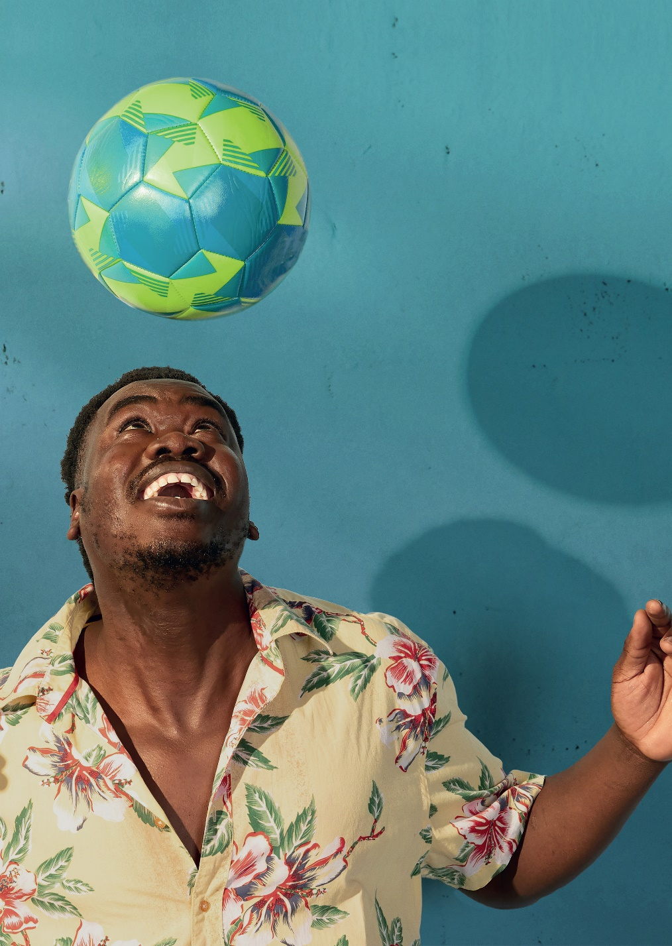
MANDELA | I used to play this scenario in my mind, where I made it to the Australian national soccer team, playing alongside Tim Cahill and representing my country Australia. I play like my hero Rivaldo, supplying Tim with the ball and he scores. We get to the world cup final against France. Then it'll be a tough game, nil nil first half, then France scores one in the second half, we apply pressure on France, the ball comes off Paul Pagba, dribble between two players, see Timmy, straight ball between their defenders, Timmy gets it and puts it in the back of the net. We celebrate. Australia celebrates. Five minutes to the end of the game, we got a corner, ball gets crossed, ball is hit out of their box by their defender, I get it, I control, cheat the defender that's on my way, in a snap second see the post, belt the shot top right corner in the 90*. It's a goal, I run to the fans celebrating. 4 secs ref blows the final whistle. Australia is in the history books, a fan gives me an Australian flag and I sing the anthem proudly. It’s a dream but it's a beautiful dream, isn't it?

